Q. Write a C program to add 2 polynomials which are represented using linked list and store the result in the resultant linked list.

A. #include<stdio.h>

#include<stdlib.h>

struct node{

float coeff;

int expo;

struct node\* link;

};

struct node\* insert(struct node\* head, float coeff, int expo) {

struct node\* temp;

struct node\* newp = malloc(sizeof(struct node));

newp->coeff = coeff;

newp->expo = expo;

newp->link = NULL;

if (head == NULL || expo < head->expo) {

newp->link = head;

head = newp;

} else {

temp = head;

while (temp->link != NULL && temp->link->expo >= expo)

temp = temp->link;

newp->link = temp->link;

temp->link = newp;

}

return head;

}

struct node\* create(struct node\* head){

int n;

float coeff;

int expo;

printf("Enter the no of terms: ");

scanf("%d",&n);

for(int i=0; i<n; i++){

printf("Enter the coefficient for term %d: ",i+1);

scanf("%f",&coeff);

printf("Enter the exponent for term %d: ",i+1);

scanf("%d",&expo);

head=insert(head,coeff,expo);

}

return head;

}

void print(struct node\* head){

if(head==NULL)

printf("No polynomial...");

else{

struct node\* temp=head;

while(temp!=NULL){

printf("%.1fX^%d",temp->coeff,temp->expo);

temp=temp->link;

if(temp!=NULL)

printf(" + ");

else

printf("\n");

}

}

}

void polyadd(struct node\* head1, struct node\* head2) {

struct node\* ptr1 = head1;

struct node\* ptr2 = head2;

struct node\* head3 = NULL;

struct node\* temp = NULL;

while (ptr1 != NULL && ptr2 != NULL) {

if (ptr1->expo == ptr2->expo) {

float coeff = ptr1->coeff + ptr2->coeff;

if (coeff != 0) {

head3 = insert(head3, coeff, ptr1->expo);

}

ptr1 = ptr1->link;

ptr2 = ptr2->link;

} else if (ptr1->expo > ptr2->expo) {

head3 = insert(head3, ptr1->coeff, ptr1->expo);

ptr1 = ptr1->link;

} else {

head3 = insert(head3, ptr2->coeff, ptr2->expo);

ptr2 = ptr2->link;

}

}

while (ptr1 != NULL) {

head3 = insert(head3, ptr1->coeff, ptr1->expo);

ptr1 = ptr1->link;

}

while (ptr2 != NULL) {

head3 = insert(head3, ptr2->coeff, ptr2->expo);

ptr2 = ptr2->link;

}

printf("The polynomial after addition: ");

print(head3);

}

int main(){

struct node\* head1=NULL;

struct node\* head2=NULL;

printf("Enter the polynomial A \n");

head1=create(head1);

printf("Enter the polynomial B \n");

head2=create(head2);

polyadd(head1,head2);

return 0;

}

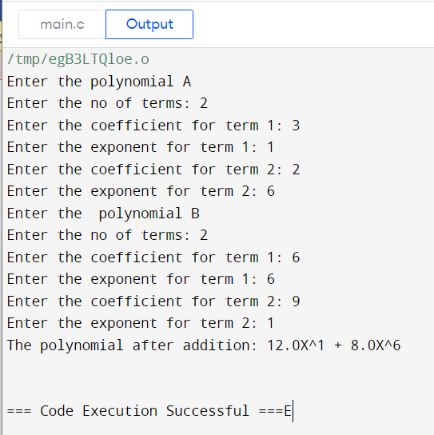

Q)Write a C program to add two polynomials where for the first polynomial is required to be represented using a linked list. For the 2nd polynomial instead of creating a new linked list, add coefficients as soon as you get it as an input from the user. In this entire process you will create only one linked list for two polynomials and for result also

A)#include<stdio.h>

#include<stdlib.h>

struct node{

float coeff;

int expo;

struct node\* link;

};

struct node\* insert(struct node\* head, float coeff, int expo) {

struct node\* temp;

struct node\* newp = malloc(sizeof(struct node));

newp->coeff = coeff;

newp->expo = expo;

newp->link = NULL;

if (head == NULL || expo < head->expo) {

newp->link = head;

head = newp;

} else {

temp = head;

while (temp->link != NULL && temp->link->expo >= expo)

temp = temp->link;

newp->link = temp->link;

temp->link = newp;

}

return head;

}

struct node\* create(struct node\* head){

int n;

float coeff;

int expo;

printf("Enter the no of terms: ");

scanf("%d",&n);

for(int i=0; i<n; i++){

printf("Enter the coefficient for term %d: ",i+1);

scanf("%f",&coeff);

printf("Enter the exponent for term %d: ",i+1);

scanf("%d",&expo);

head=insert(head,coeff,expo);

}

return head;

}

void print(struct node\* head){

if(head==NULL)

printf("No polynomial...");

else{

struct node\* temp=head;

while(temp!=NULL){

printf("%.1fX^%d",temp->coeff,temp->expo);

temp=temp->link;

if(temp!=NULL)

printf(" + ");

else

printf("\n");

}

}

}

void polyadd(struct node\* head1){

int n;

float coeff;

int expo;

printf("Enter the no of terms for 2nd polynomial: ");

scanf("%d",&n);

for(int i=0; i<n; i++){

printf("Enter the coefficient for term %d: ",i+1);

scanf("%f",&coeff);

printf("Enter the exponent for term %d: ",i+1);

scanf("%d",&expo);

struct node\* temp = head1;

while(temp->link != NULL) {

if(temp->link->expo == expo) {

temp->link->coeff += coeff;

break;

} else if(temp->link->expo < expo) {

struct node\* newp = malloc(sizeof(struct node));

newp->coeff = coeff;

newp->expo = expo;

newp->link = temp->link;

temp->link = newp;

break;

}

temp = temp->link;

}

if(temp->link == NULL) {

struct node\* newp = malloc(sizeof(struct node));

newp->coeff = coeff;

newp->expo = expo;

newp->link = NULL;

temp->link = newp;

}

}

printf("The polynomial after addition: ");

print(head1);

}

int main(){

struct node\* head1=NULL;

printf("Enter the 1st polynomial \n");

head1=create(head1);

polyadd(head1);

return 0;

}

